
CYB 150-T01 Cybersecurity Foundations
MODULE 7: CHAPTER 9: PROJECT 9.1

October 24, 2025

Professor: Karry Elson
Student: Jamison Durham

Table of Contents
Virtualization and Linux………………………………………………………………………………………………………………………2
Chapter 9: How Does the Microsoft Firewall Work?…………………………………………………………………………9
References……………………………………………………………………………………………………………………………………….13

Virtualization and Linux

Assignment:
Starting at Step 3, after downloading VirtualBox and Linux.

Step 3 -- Practice the Linux CLI. Practice with at least ten Linux commands at the command line interface (CLI).

For the report, take screenshots with a caption for each. Use the Linux Introduction handout from class for any help here. Comment on your overall impression of Linux so far.

Notes: For the report, you do not need to show the detailed installation process for VirtualBox (or any similar virtualization software). Likewise, you do not need to show the installation process of your Linux distribution. However, you do need to provide screenshots showing that you are running virtualization software (e.g. VirtualBox) and running Linux with it.

Assignment response:
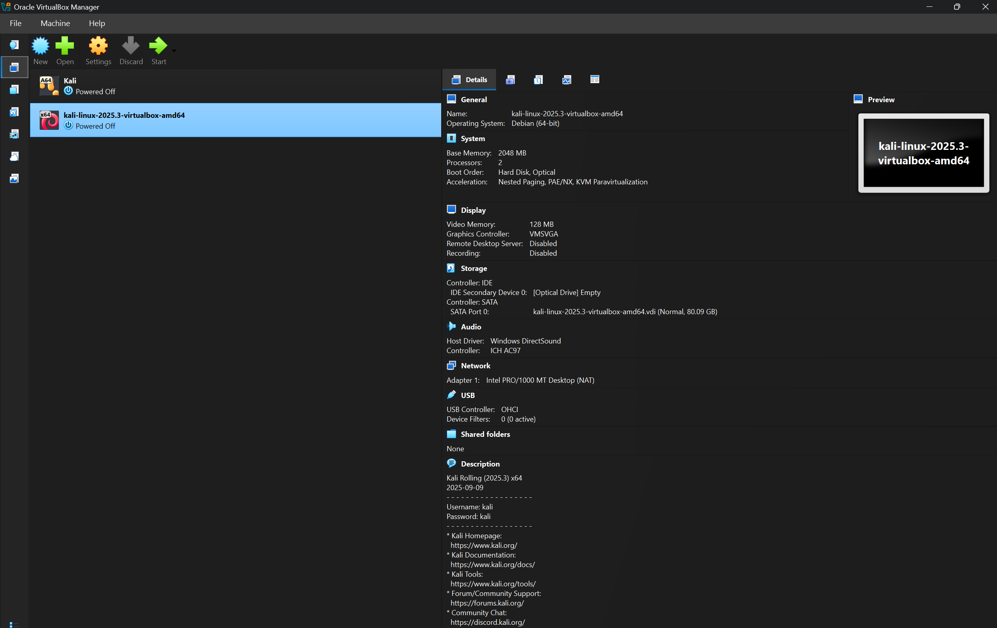
Here is the Virtual Box hosting the updated version of Kali Linux. After many hours of troubleshooting, I was not able to run Linux without error so the next couple of screenshots will be of information online, which can be found in the references.
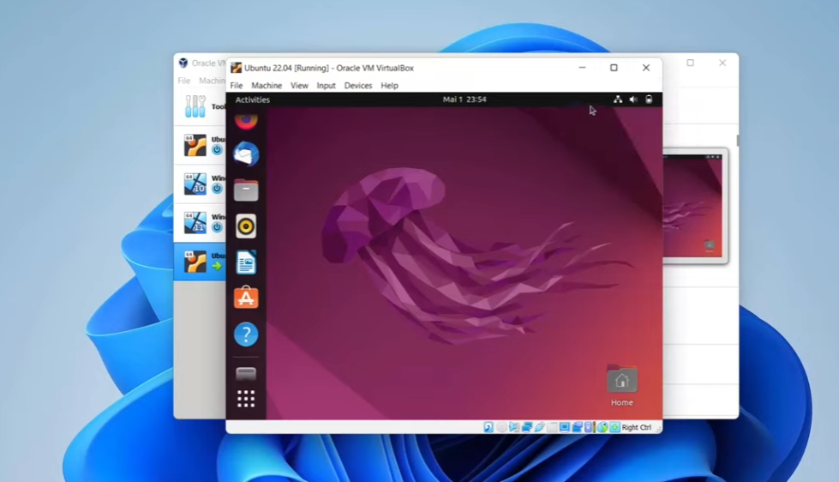
This is what it would look like to have Ubuntu running on a virtual machine such as Virtual Box.

- Command: Sudo
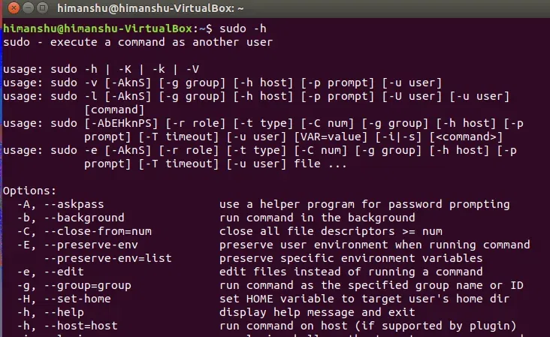
This is the Sudo command, giving the user administrative power. Sudo meaning “super user do.”

- Command: Ifconfig
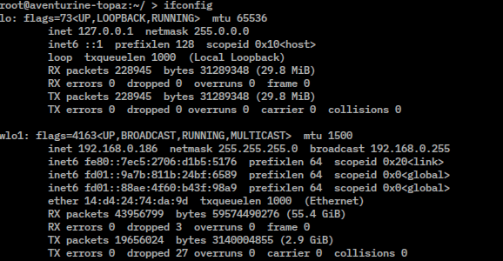
This command is the Linux version of Ipconfig on Microsoft, as it shows all of the network interface connections.

- Command: ls
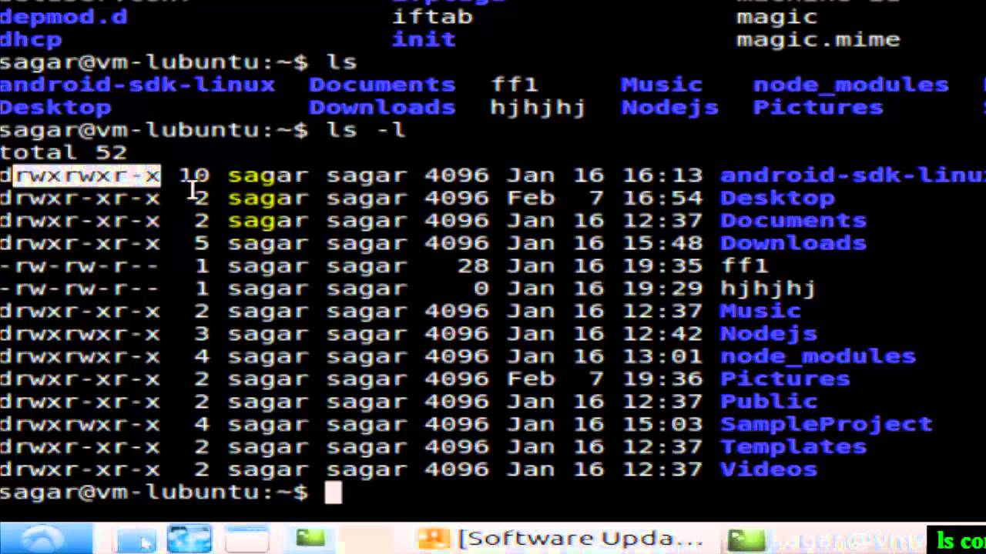
The ls command list information about the files and the current directory. The -l tells the command to limit each file to one line.

- Command: clear
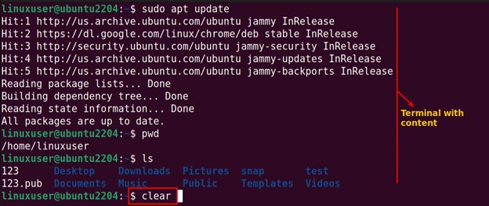
This command shows how the clear command will make a new slate for commands, clearing the terminal with content.

- Command: df -h/
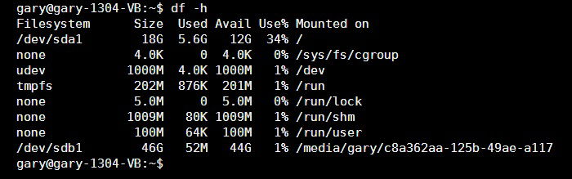
Df stands for “disk free” which shows how much space is divided among file systems. The -h stands for “human-readable” which breaks the data into GD, MB, and KB to allow the user to better understand where the space is being used.

- Command: history
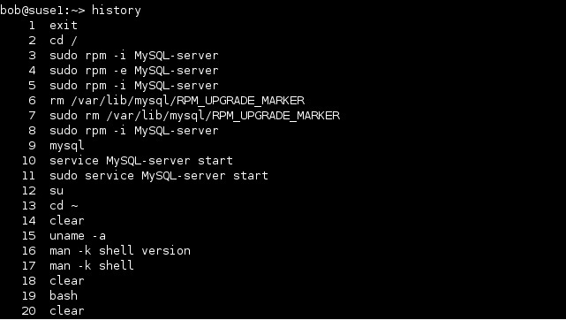
As states in the command, this shows all of the recently typed commands by the user.

- Command: open ‘filename’
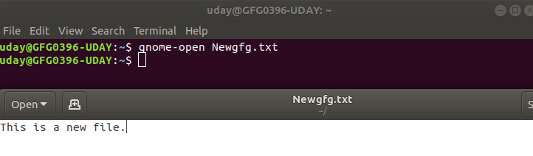
This is an example of the user using the open command, commanding a specific file which can be seen at the bottom of the screen.

- Command: last $USER
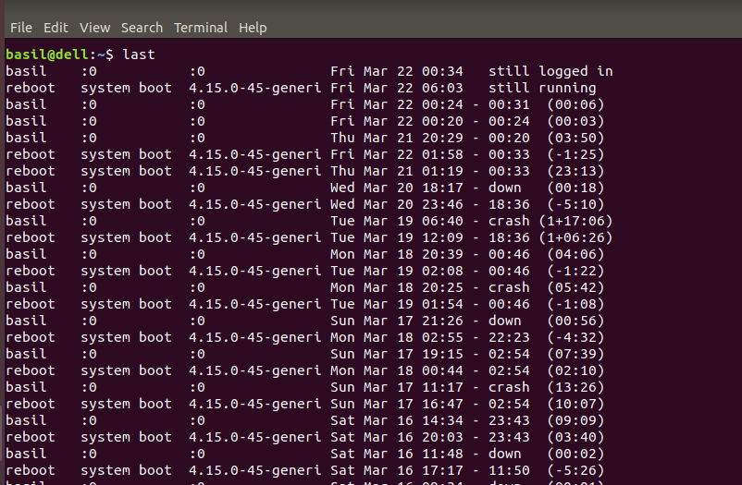
This shows the user using the last command, showing the time of the log-ons although you can command a specific user after the last command.

- Command: echo
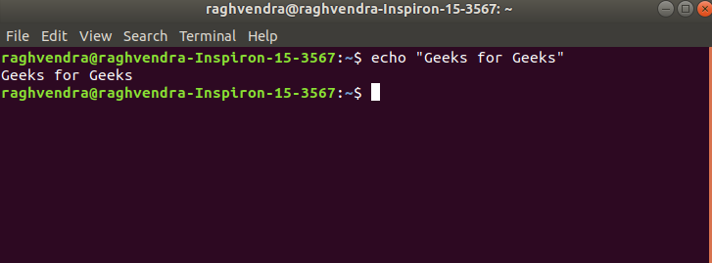
Echo allows the user to input text and to receive the printed text in the terminal or file.

- Command: pwd
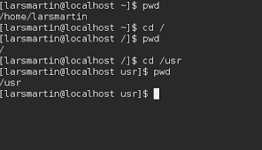
To print the working directory, the pwd command displays the current available directory.

Overall, Linux can be an in-depth OS with lots to offer. Even though I was not able to practice these on my own, I believe that Linux can be easy to learn with some basic terminology.

cHApter 9: hOW dOES THE miCROSOFT fIREWALL wORK?

Assignment:
How Does the Microsoft Firewall Work?

Using Microsoft documentation, the Web, and other resources, find out what methodologies the Microsoft Windows (whichever version you are using) firewall uses. Write a brief essay explaining the strengths and weaknesses of that approach. Also discuss situations in which you feel that approach is adequate and those in which it might be inadequate.

Students complete Project 9.1, "How Does the Microsoft Firewall Work?" (note: Not Exercise 9.1) Please include multiple screenshot(s) with captions. The write-up should be about one full page of text single-spaced or two pages double-spaced.
In answering this question, whether you write about firewalls on Windows or a Mac, conduct some research and provide a security analysis of your firewall -- is it easy to use? effective? Is the firewall turned on by default or does the user need to turn them on?

Assignment response:

Personal Research:
Before writing the essay, I will conduct some personal research about my own Microsoft Firewall.

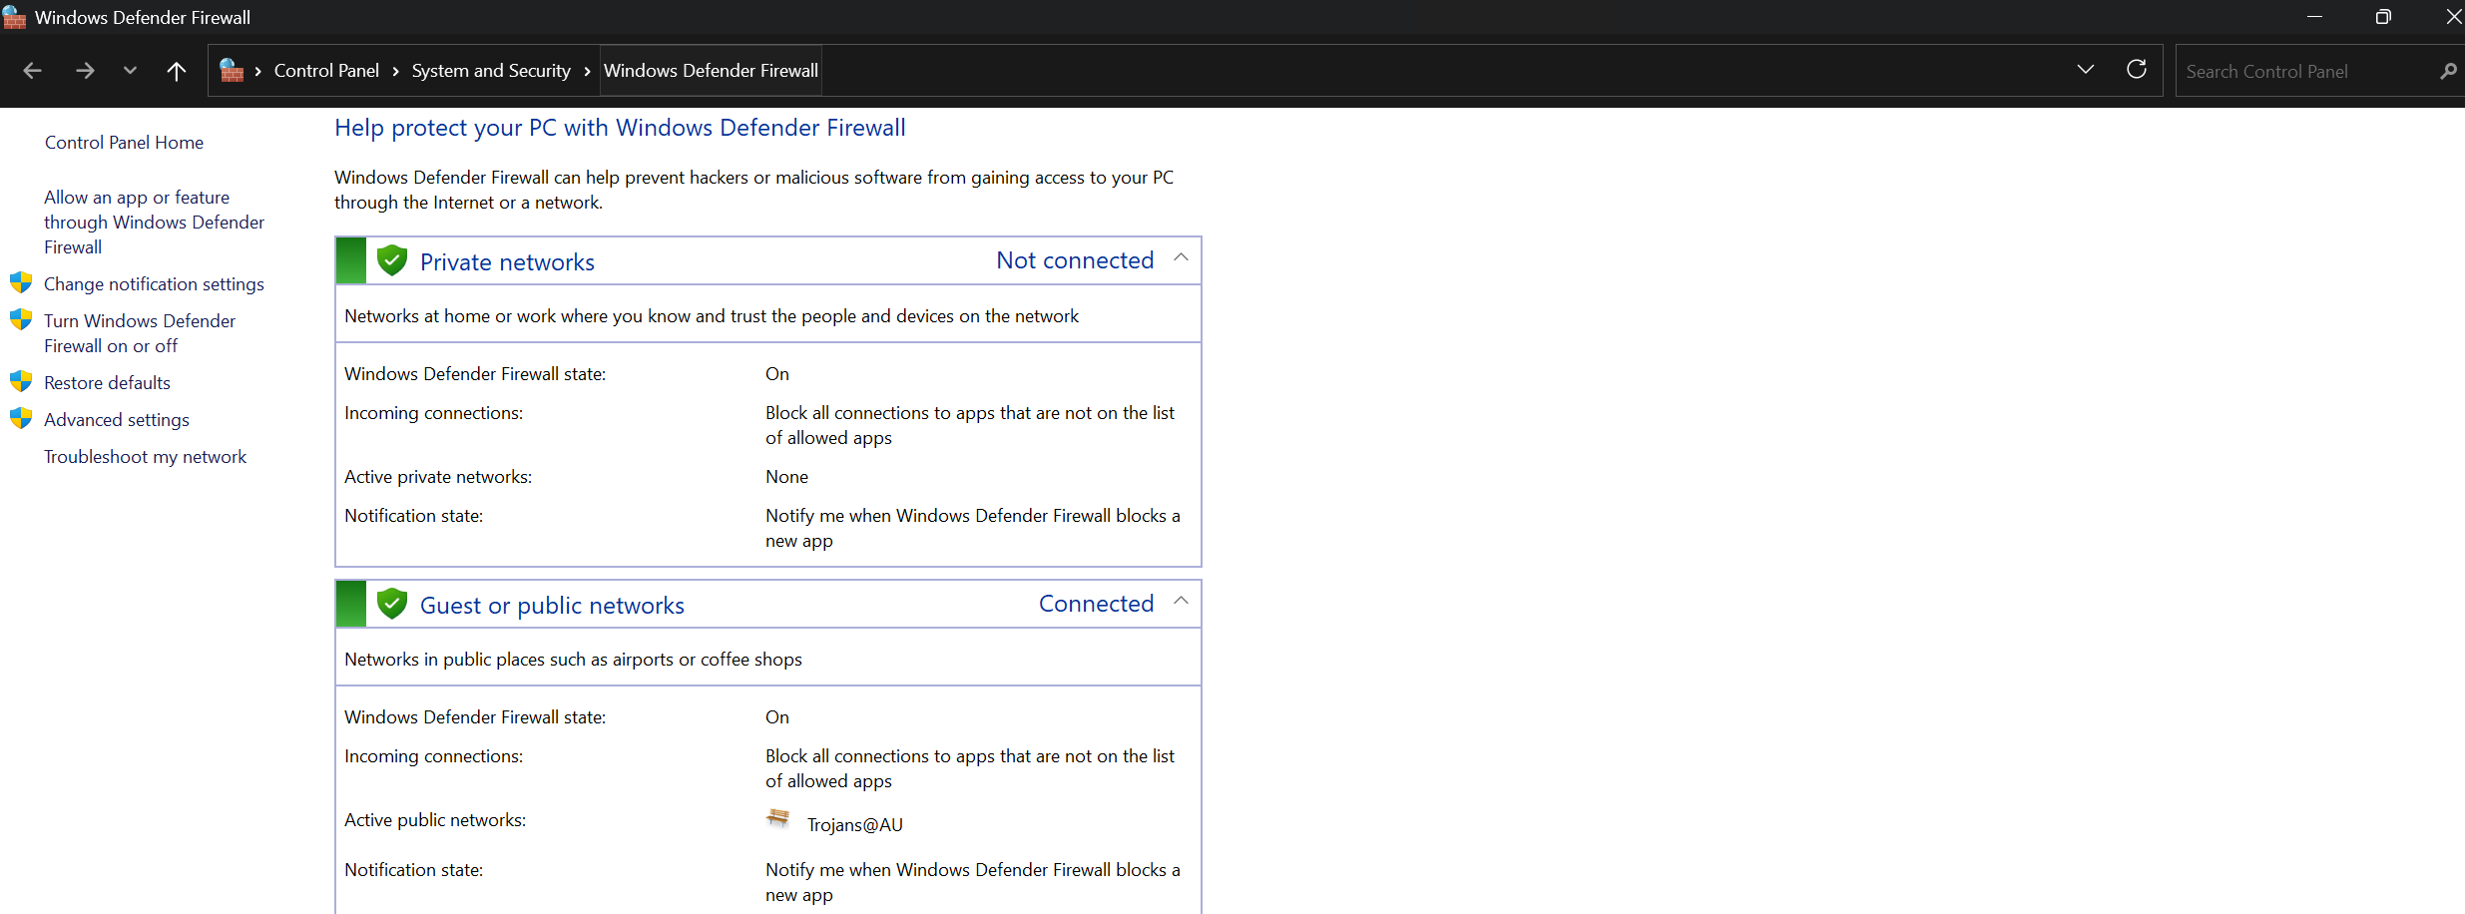
Just from the search bar in settings, I was able to check on the status of my firewall. Both private and public networks are protected by the firewall. Private networks are not connected although the firewall status is on. Notifications are also on for malicious behavior.

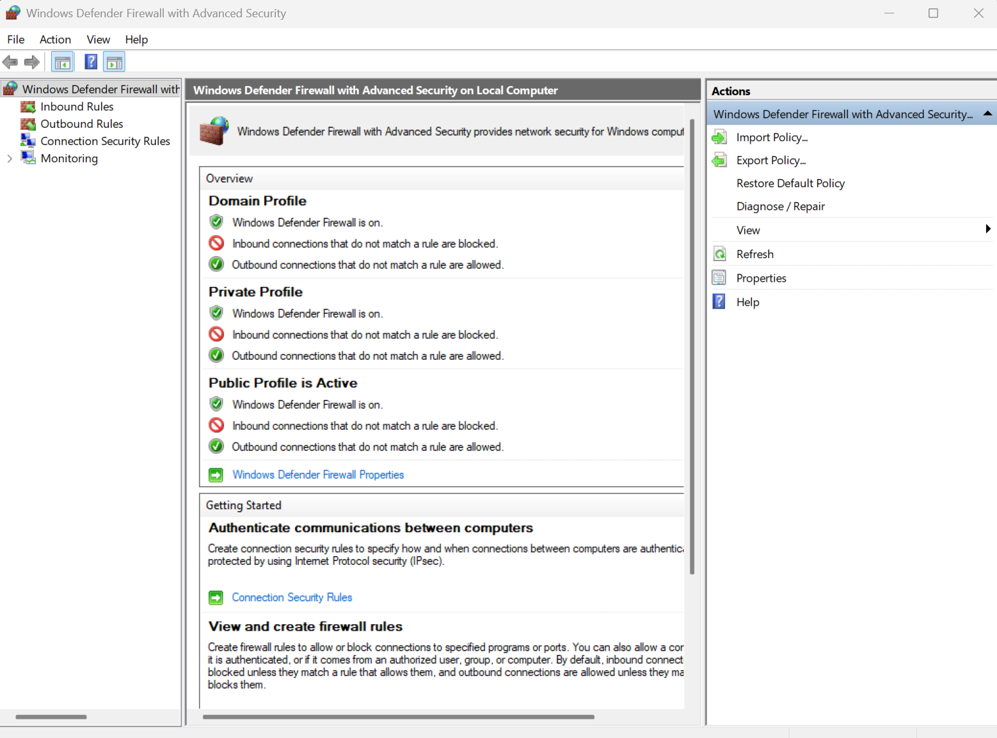
As stated in a previous exercise, a user is able to access the advanced security, adding inbound or outbound rules.

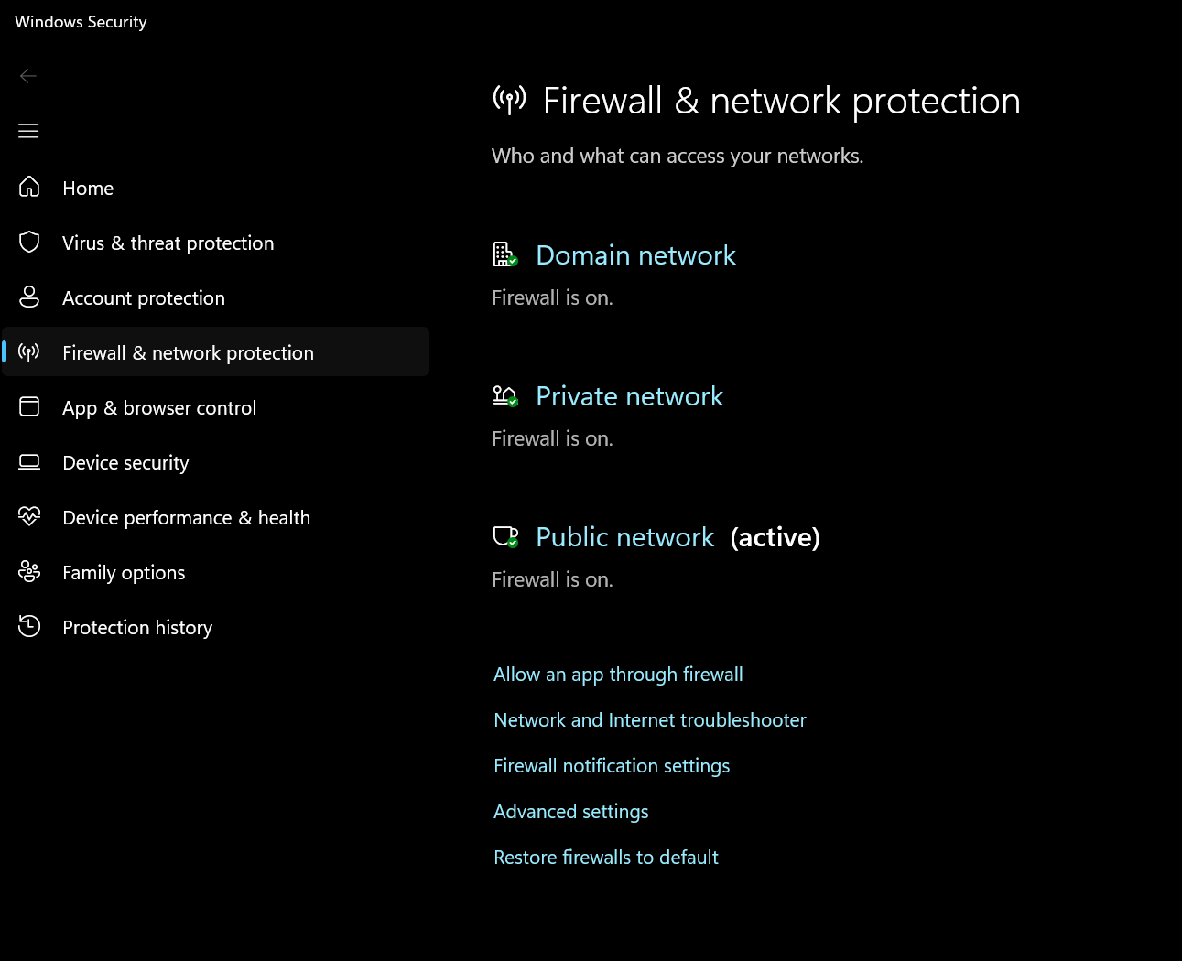
This is another example of how the security system covers both private and public networks, as well as domain networks.
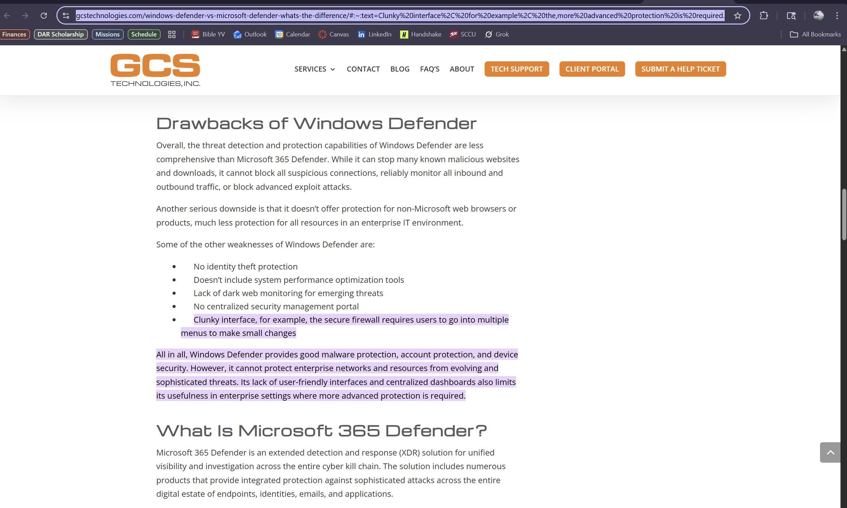
An example from one of the sources used in the essay below. This explains some drawbacks when using Microsoft’s Defender Firewall.

Research Essay:

Windows Firewall is vital in assuring the security of the computing systems of Windows as it filters internet traffic entering and leaving a Microsoft device. This is regulated by Microsoft’s Window’s Filtering Platform (WFP), through a set of inbound and outbound set of rules. Inbound and outbound rules can be matched by IP addresses, ports, protocols, and other custom criteria created by the user.
Microsoft Firewall is said to be easy to use by users, as it is accessible through the settings application. By using the search feature, you can find multiple directories to Microsoft’s Defender Firewall. You can check the firewall status, checking to see if it covers both the private and public networks. If the firewall is turned off, you can turn this on through the Windows Security app. You may also turn the security system off through the same app, although this is highly discouraged as it leaves the individuals computer vulnerable to threats and attacks.
Microsoft released an article earlier this year discussing whether the firewall is safe enough for just the user, or if their users should purchase another firewall. The article states that the security system can provide strong and secure protection. As well as the decent performance and usability scores in independent test. The firewall is able to block many threats, staying up to date with the latest threats and detection methods. Although the article had a lot of well-rounded and decent things to say about their company’s firewall, Microsoft also mentioned that some third-party firewalls and protection systems might offer more security as they have more specific prevention techniques for certain types of attacks. For example, some third-party firewalls might be able to protect against phishing or DoS attacks in a more secure manner rather than Microsoft’s latest firewall.
As stated previously, Microsoft offers and amazing free firewall for their systems, although there are some downsides with the security system. Microsoft does lack some security in phishing protection, as they recommend other parties for better security measures. This goes to prove the claim that Microsoft made earlier, additional security such as VPNs, detection systems, and identity theft can provide more security than just the basic firewall that is offered. The main takeaway from the downsides is that there is always more security to posses when using a computer, especially with access to the internet.
Microsoft offers many strengths for their users assuring better security for their customers. For example, the firewall offers real-time protection, constantly monitoring incoming out out-going traffic in order to block intrusions and threats. Microsoft also has a well-known reputation for their high performance, reflecting positive results for their independent and self-ran test. A lot of these tests were run without slowing down the system, which is a major positive for the overall integrity of the company. Another obvious positive is that the firewall is included with the purchase of the device.
Overall, Microsoft’s defender firewall is capable of protecting their users, as it is easy to use, effective for the price, flexible with inbound and outbound rules and protocols, and even the ability to disable or enable the firewall when needed. It is always better for companies that use Microsoft’s products to have extra layers of security to protect sensitive data and information, not to rely just on the firewall Microsoft offers. Although, regular consumers, browsers, and families should not be concerned to the extent that other businesses should be. With all things considered, everyone should monitor their security, whether it be through additional security systems, VPNs, or even threat detections programs in order to maximize security and protection of vulnerable data.

References

- https://linuxgenie.net/clear-terminal-screen-ubuntu/
- https://www.maketecheasier.com/linux-df-du-commands/
- https://geek-university.com/command-line-history/
- https://learn.microsoft.com/en-us/windows/win32/fwp/windows-filtering-platform-start-page
- https://www.gcstechnologies.com/windows-defender-vs-microsoft-defender-whats-the-difference/#:~:text=Clunky%20interface%2C%20for%20example%2C%20the,more%20advanced%20protection%20is%20required.
- https://learn.microsoft.com/en-us/answers/questions/3892190/is-windows-defender-safe-enough-or-do-i-need-to-bu

